REQUIREMENT ANALYSIS

Data Flow Diagrams and User Stories
Date | 29 September 2026 | Team ID: [Enter Team ID]
Project Name: AI-powered FAQ and Customer Support Automation (AnswerBot)

Data Flow Diagram
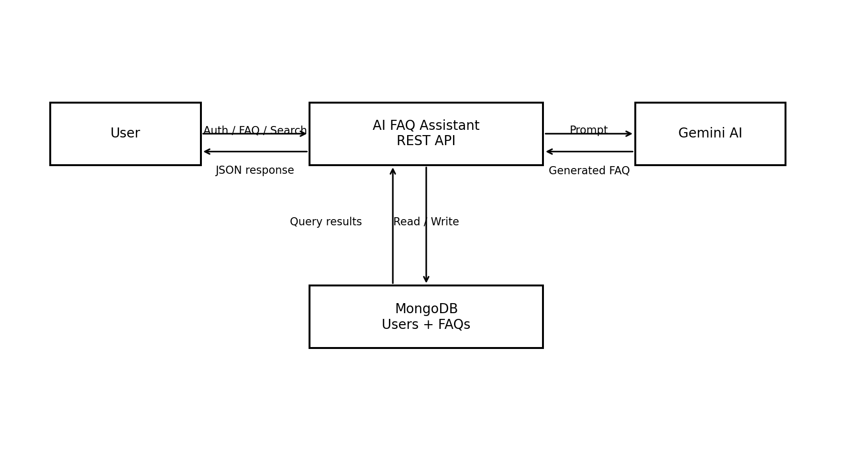
The user exchanges authentication, FAQ and search data with the REST API. The API reads/writes user and FAQ documents in MongoDB and calls Gemini only for AI-generation requests.

User Stories
User Type | Epic | Story No. | User Story / Task | Acceptance Criteria | Priority | Release
Support User | Registration | USN-1 | As a user, I can register using my name, email and password. | Account is created; duplicate email is rejected. | High | Sprint-1
Support User | Login | USN-2 | As a user, I can log in with valid credentials. | A JWT is returned for valid credentials. | High | Sprint-1
Creator | FAQ Management | USN-3 | As a creator, I can add an FAQ. | FAQ is validated and stored with creator reference. | High | Sprint-2
Creator | FAQ Management | USN-4 | As a creator, I can edit my FAQ. | Authorized update succeeds; unauthorized update fails. | High | Sprint-2
Creator | FAQ Management | USN-5 | As a creator, I can delete my FAQ. | Authorized delete removes the document. | High | Sprint-2
Public User | Search | USN-6 | As a user, I can search FAQs with a query. | Relevant FAQ records are returned. | High | Sprint-3
Creator | AI Generation | USN-7 | As a creator, I can generate FAQ drafts from a topic. | Gemini returns structured FAQ content or a handled error. | High | Sprint-3
Admin | Administration | USN-8 | As an admin, I can manage protected system content. | Admin authorization allows elevated actions. | Medium | Sprint-4

